Healthy Places, Participatory Budgeting Project for Health & Equity at the GSD
Amy Brooks Thornton. MDES: Risk and Resilience, 2020
athornton@gsd.harvard.edu
November 2019

Email to: healthyplacesgsd@gmail.com

- Outdoor Working, Learning, Socializing (OWLS): Inspiring and facilitating behavioral health in partnership with the natural environment

- Amy Brooks Thornton (I am open to co-participants!)

3. Project Plan
Conceived as a specific response to the statistics that the United States population spends nearly 90% of its time indoors and a concern over the human and environmental health implications of that statistic particularly as it is manifested and experienced at the GSD, I propose a structure made in partnership with the natural environment to inspire and facilitate outdoor learning, working, and socializing. Based the practice of behaviors for health in partnership with the natural environment, “ecological behavioral health”, I hope to ignite speculation for a new paradigm of contemporary being as an act of co-creation with the other-than-human in order to improve mental and physical wellbeing.

I will research, design, and build a transformable and compostable outdoor working, learning, and socializing structure (OWLS) for human and environmental health. OWLS will strive to inspire co-creation, re-connection, and oneness with the natural environment and be informed by whole systems design, which considers and defines the “whole” system rather than individual parts (holism), recognizes the critical role of relationships between elements of the system (interdependence), and influence of each element on the system (effects). It arises from evidence-based research to promote ecological behavioral health (a form of whole systems thinking), theory regarding sequestering, interiority and exteriority, and the opaque versus the trans-sensory, and provides opportunity for experiential learning about compostable design, circular systems, behavioral health and immersion in and full-sensory exposure to the outdoor environment. And PLAY!

OWLS is small cluster of outdoor structures for work and learning, such as outdoor standing and cycle desks, that can be transformed into a variety of configurations to serve meetings, classes, social events, play, and relaxation. Even sleep! OWL is free for anyone in the Harvard community to use, including building staff, administrators, students, faculty, and guests.

4. Core values. Why is OWL urgent?
Globally, the leading cause of death and disability are non-communicable diseases (NCDs) which kill more than three in five people worldwide and responsible for more than half of the global burden of disease (Kaiser Family Foundation, 2019, WHO 2016). NCDs undermine general wellbeing, healthy aging, and can lead to major depression (Egede, 2007).

Human behavior is a significant factor driving NCDs (Kaiser Family Foundation, 2019, WHO 2016). Sedentary, indoor, sleep deprived, nutrient impoverished, high-stress, relentlessly connected, and fossil-fuel driven lifestyles not only burden the healthcare system and drive up health care costs, (WHO 2016, Hoskins 2003, Tremblay 2010,… ) they also disconnect people from knowing, connecting and caring for the natural environment, stoke global warming, and pollute the air, water, and soil. The United States population spends 87% of their time indoors and 6% in an enclosed vehicle (on average). Indoor air pollution is found to be two to five times greater than outdoors (Klepeis et al, 2001).

Our campuses are no exception. Rates of depression, anxiety, and suicidal thoughts among college age students is rising rapidly. Suicidal ideation rates alone soared from 5.8% in 2007 to 10.8% in 2017 (Lipson, et al, 2018). Important in the context of Harvard, graduate students are disproportionately likely to experience mental health issues, according to a study the university conducted last year (Barreira et al, 2018). Providing a test site for hybrid forms of learning and working establishes a physical invitation to members of the GSD community to explore alternatives to sedentary, indoor—and often times solitary—methods of accomplishing tasks, and goals and creative functioning.

Alternatively, behaviors in support of mental health and physio-emotional wellbeing can also reduce anthropogenic harm to the natural environment and increase local energy feedback loops. An abundance of research (Ulrich, 1984, Ohtsuka, 1998, Cimprich, 2001, Loeffler, 2004, Wichrowski, 2005, Boniface, 2006, Berman, 2008, Park 2010, Van Den Berg, 2011, Wu, 2013) indicates that time spent outdoors provides a wide range of benefits for physical, mental and social health, as well as increased, concern for the environment (Broom, 2017). For example, unplugging and turning off screens, and sleeping under the dark of night increases sleep health and decreases energy dependence. Spending time outdoors in natural light increases cognitive function (Kent, 2009) and increases mood regulation (Levandovski, 2013) while reducing dependence on electricity. Walking outdoors during university seminars improved the quality of discussions, student sense of well-being and the general quality of the seminar (Bälter, 2018) while reducing demand on indoor systems.

Design which regards the natural environment as partner and considers life-cycle analysis and material geography, minimizes fuel use and maximizes energy returning to the system (day lighting, natural cross ventilation, passive solar gain, local, non-toxic, biodegradable materials, etc) is healthier for the entire system, human and other-than-human. OWLS seeks to configure object, user, and environment in a relationship that neutralizes potential harm and fosters an opportunity for both humans and other-than-humans to thrive.

Design considerations
Design considerations for OWLS would include evidence-based behaviors which directly and indirectly impact working and learning by supporting human health and wellbeing: ample sleep, physical activity, and daylight exposure, positive social intergenerational interaction and inclusivity, quiet contemplation, creativity, intellectual stimulation, full-sensory experiences, play and laughter, music, and immersion in the natural environment. Whole system design considerations will include sound, lighting, thermodynamic surfaces, environmental pollutants, material geography, ecological impact, and life-cycle and emergy analysis of materials used. Emergy analysis is a method to understand behaviors of self-organized systems and value ecological goods and services in the context of ecological and economic systems.

5. Impact and Longevity
OWLS will be built out of low impact materials to tolerate and provide work and learning space in most Northeastern weather six months out of the year (and can operate indoors during winter months). The materials will likely be local wood such as cedar that can maintain structural integrity for at least a decade with minimal maintenance—light sanding and refinishing with non-toxic finishes such as juniper or birch oils.

OWLS can be erected in the Gund Hall backyard accessible to all Harvard staff, administration, students, faculty, and the surrounding community for use, experimentation, play, and research documentation. The project can be easily deconstructed and stored by late May 2020 prior to commencement unless otherwise desired by Harvard University.

6. Budget Table
For the equivalent of approximately 4X the outdoor standing desk currently in the back yard, approximately 140” X 140” or 10’ 10” X 10’ 10” of surface area. It will be no higher than 6 feet tall at any given point. This would allow up to 16 people, or a seminar class size, to sit or stand around it. With removable covering, various sized standing platform boxes to fit human to desk, and stationary bicycles.

Lumber - recycled or locally sourced untreated lumber that weathers well such as cedar,
- approximately $300 per 2-4 person work/play area $ 1200
Extra tools - straps, clamps, sand papers $ 400
Hardware - fasteners, hinges $ 300
Adhesives and finishes – non-toxic glues, Vermont Coatings juniper, birch oil, etc $ 300
Recycled bicycle parts for two work areas $ 350
Material transportation $ 150
Volunteer labor nourishment $ 100
Custodial; office supplies;, incidentals $ 100
Subtotal $ 2900

Optional
Outdoor power station/generator for 3-5 charges see Yeti 400 Portable Power Generator $ 500
Small portable solar panel for recharging power station see Boulder 100 Solar Panel $ 300
Electrician $ 800
Subtotal $ 1600

TOTAL REQUESTED $ 4500

7. Precedent
Last spring Emily Jones (Harvard College) and I designed and built an outdoor standing desk based on the same principles and theory as outlined above. It has been in use in the Gund Hall backyard this fall. OWL would expand upon this project.

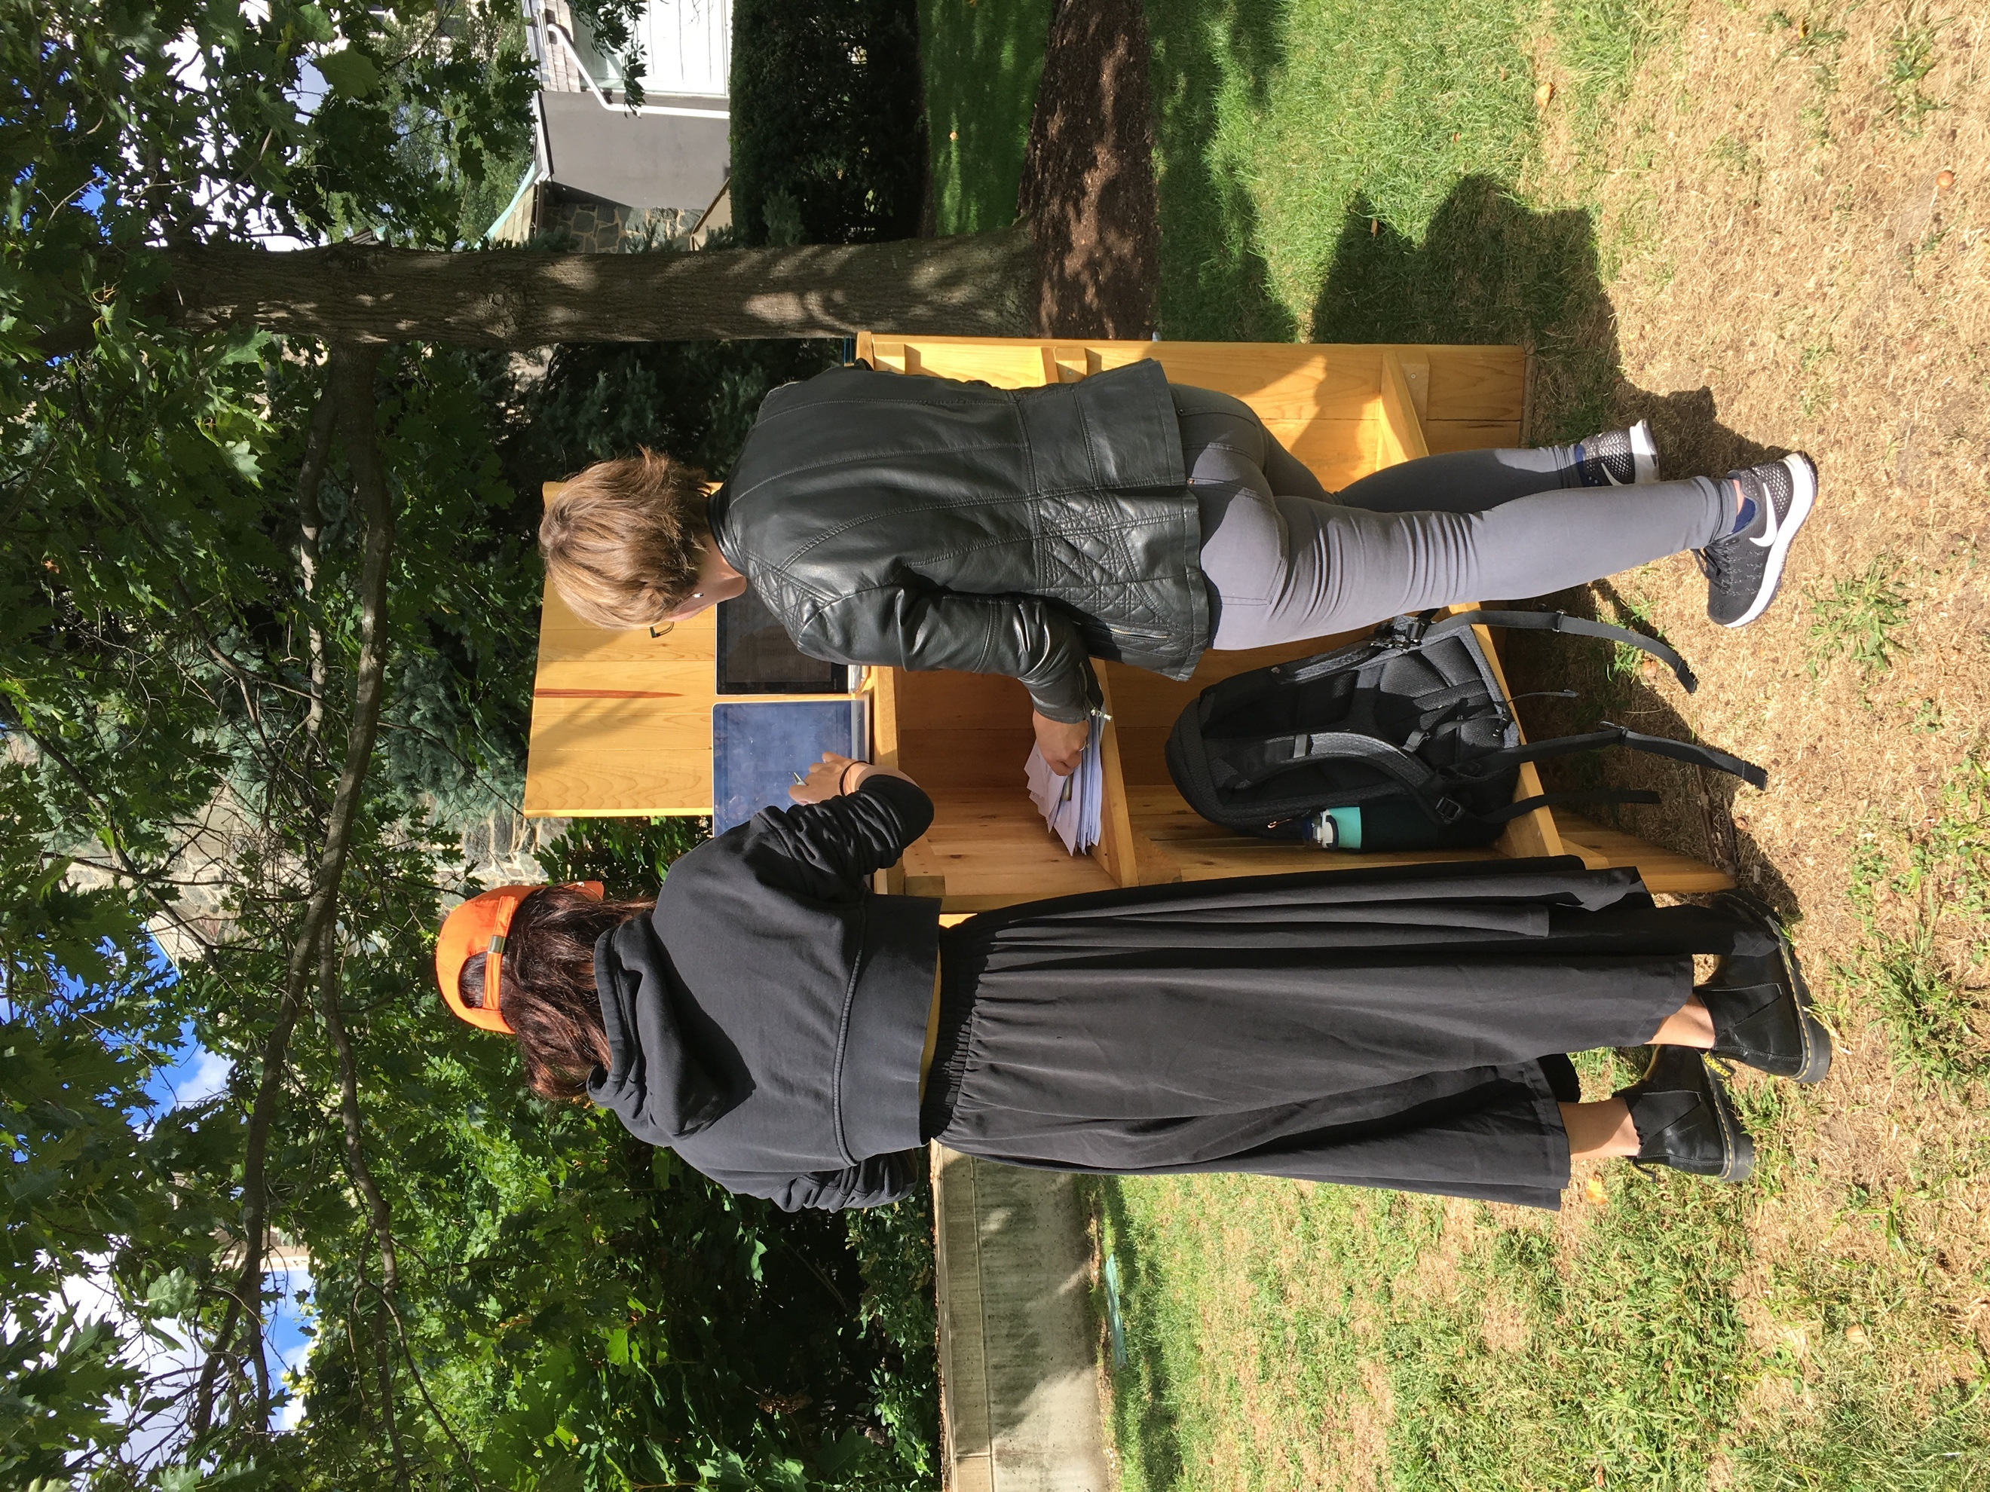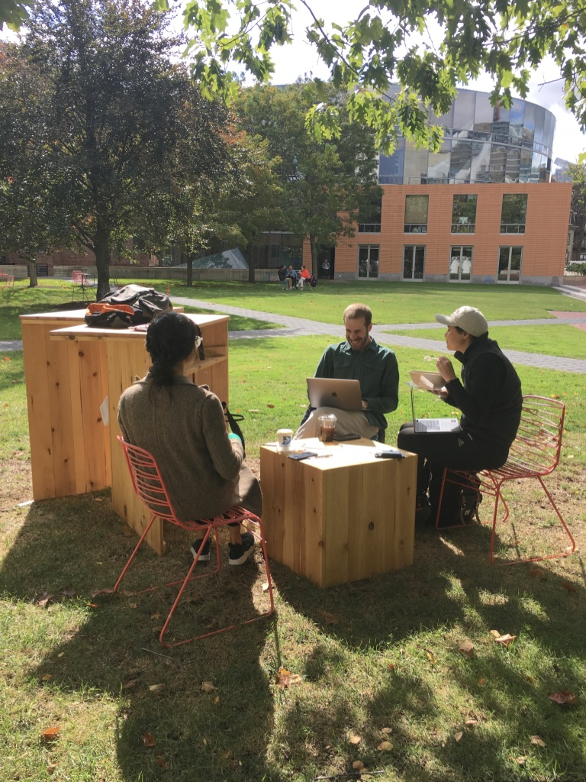

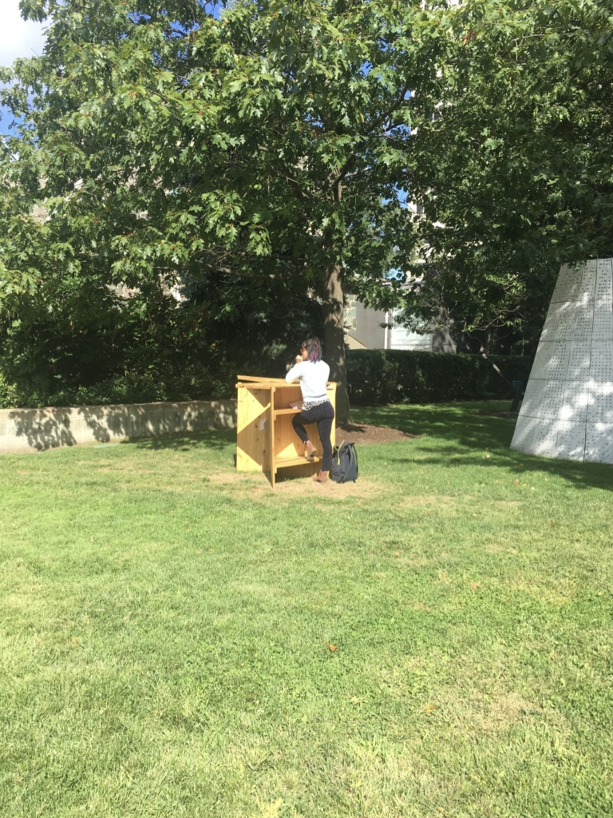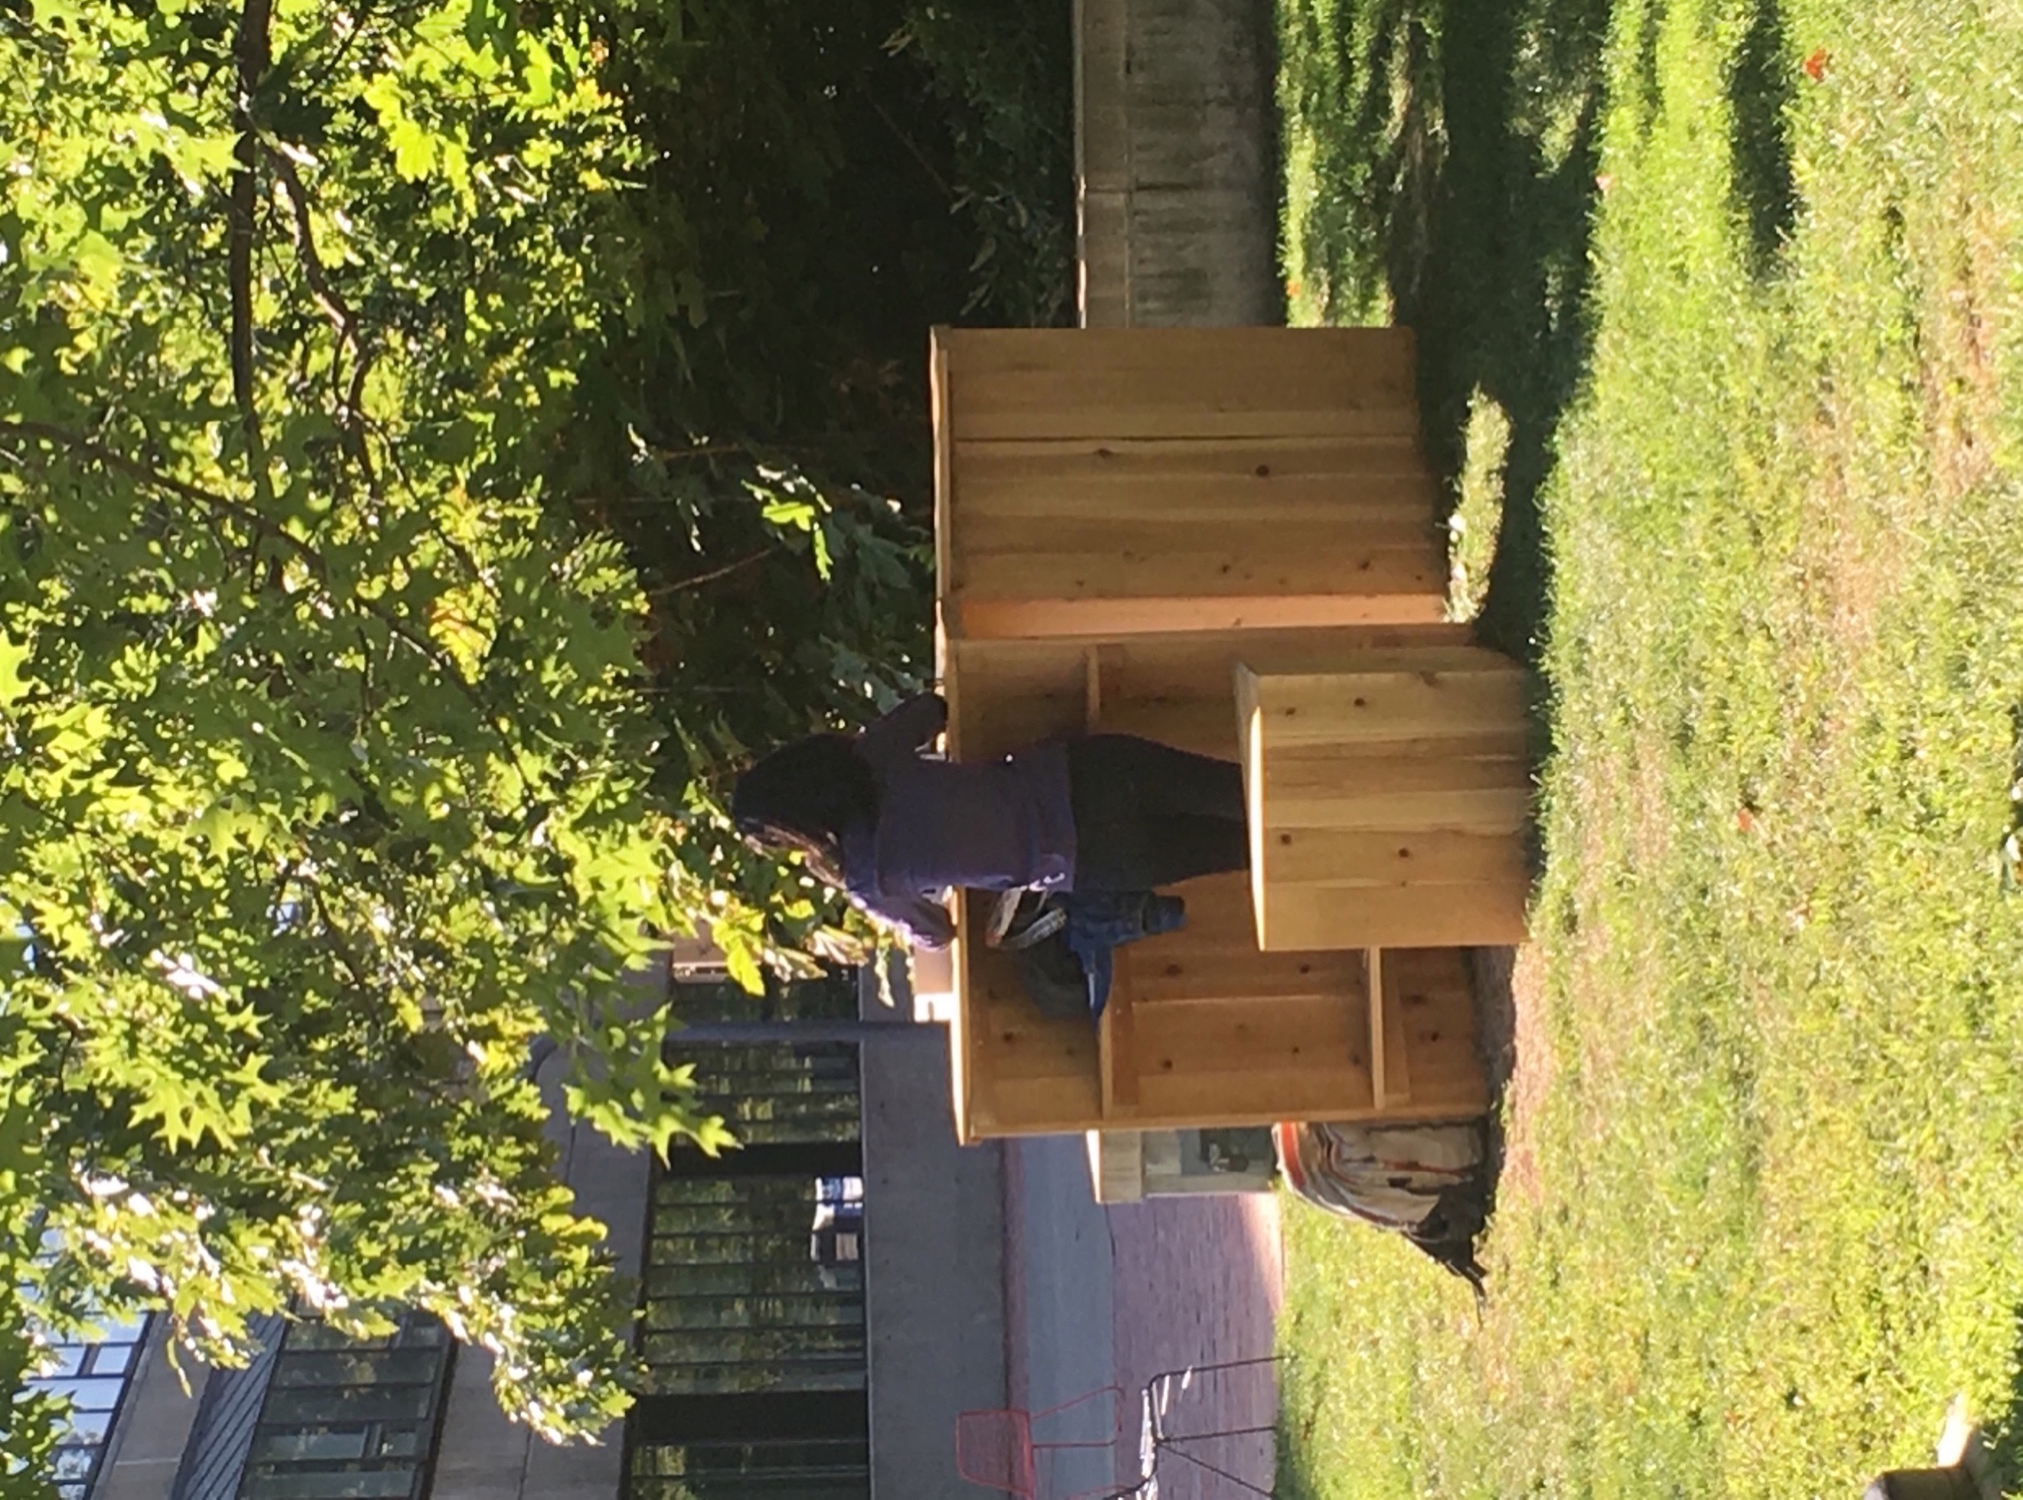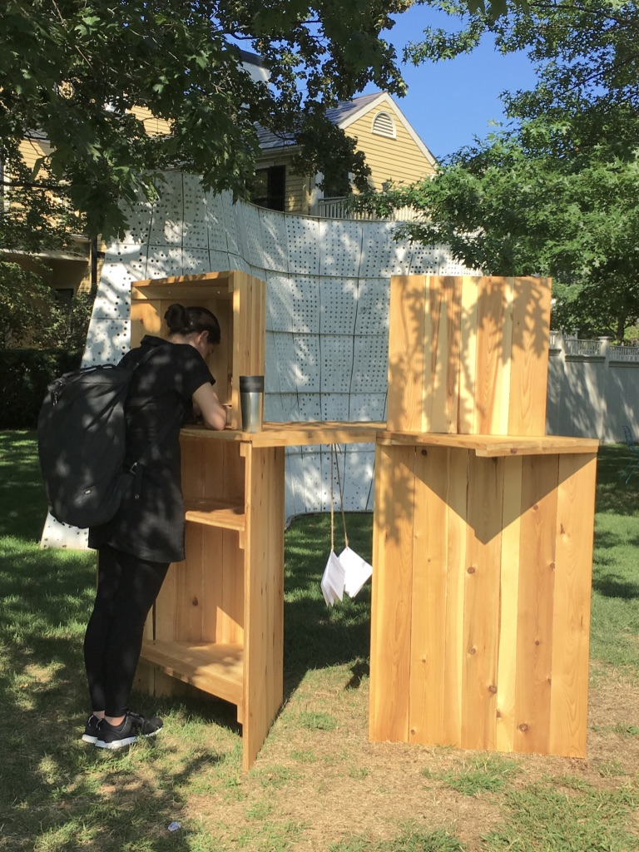

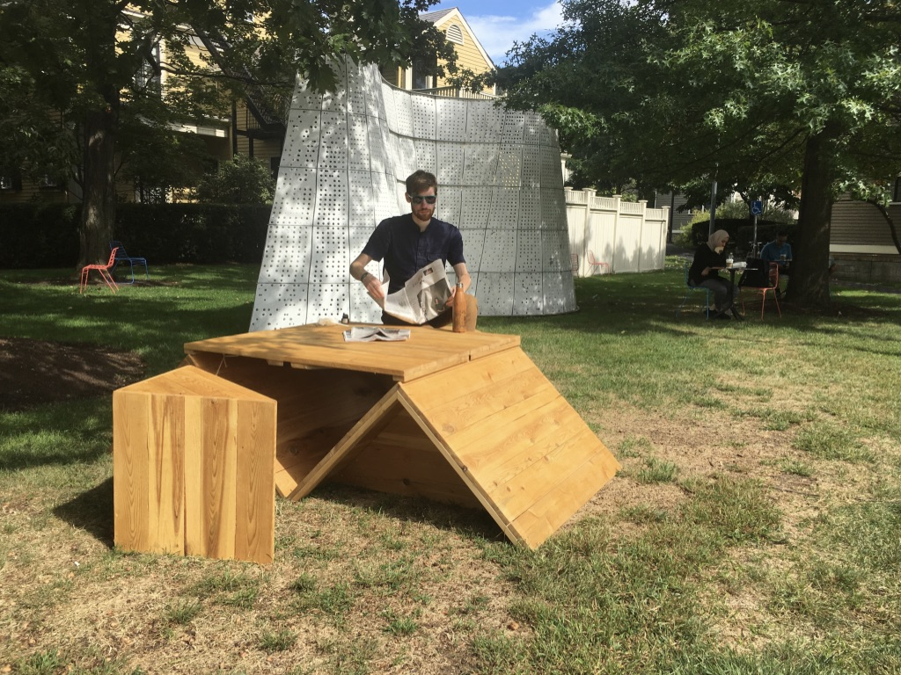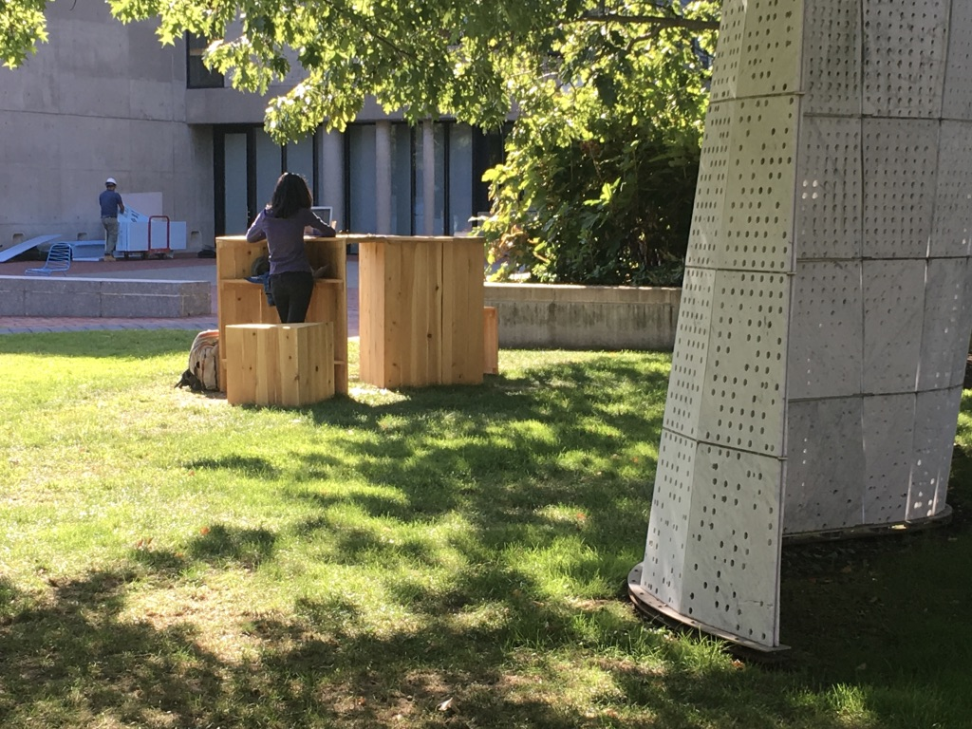
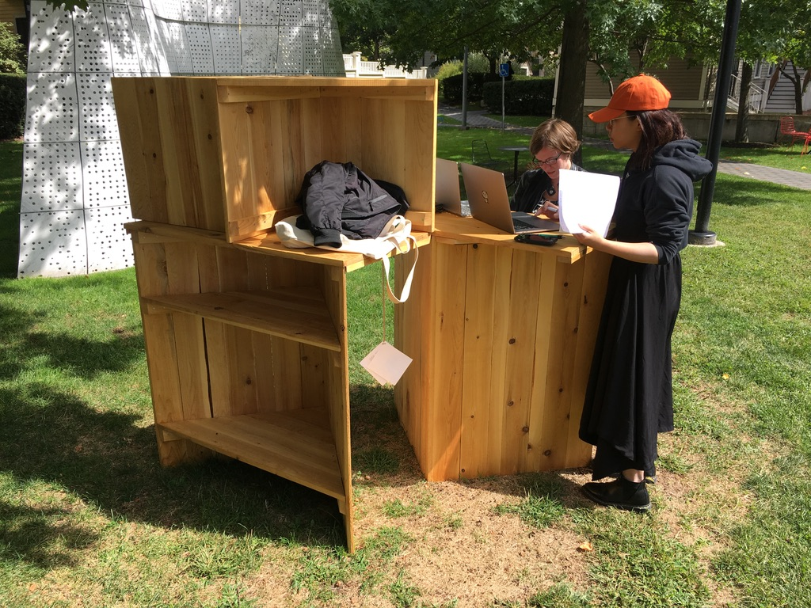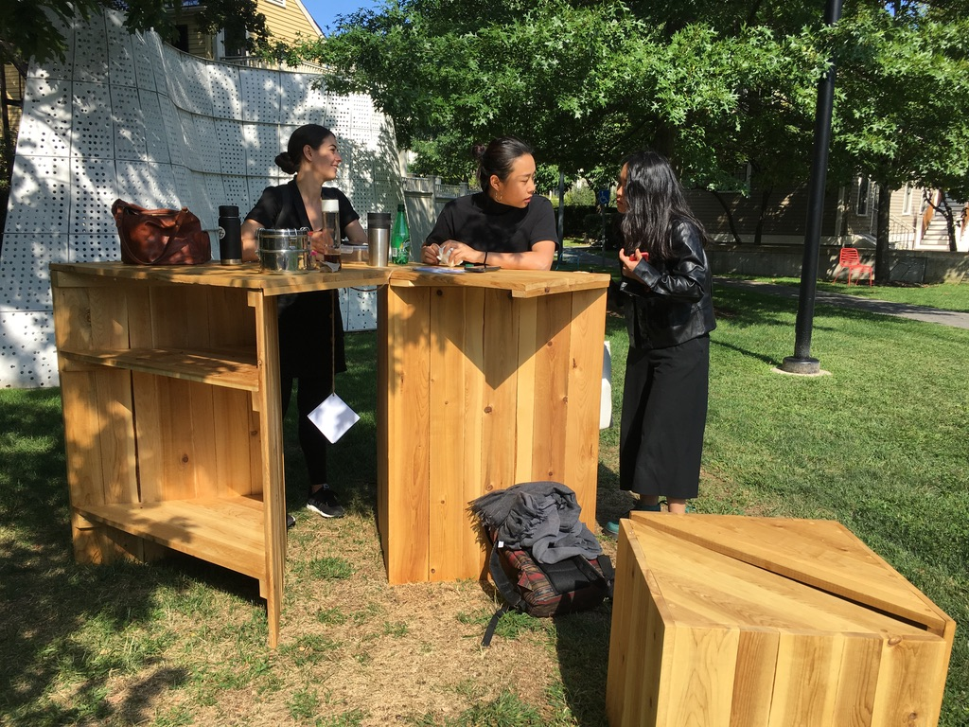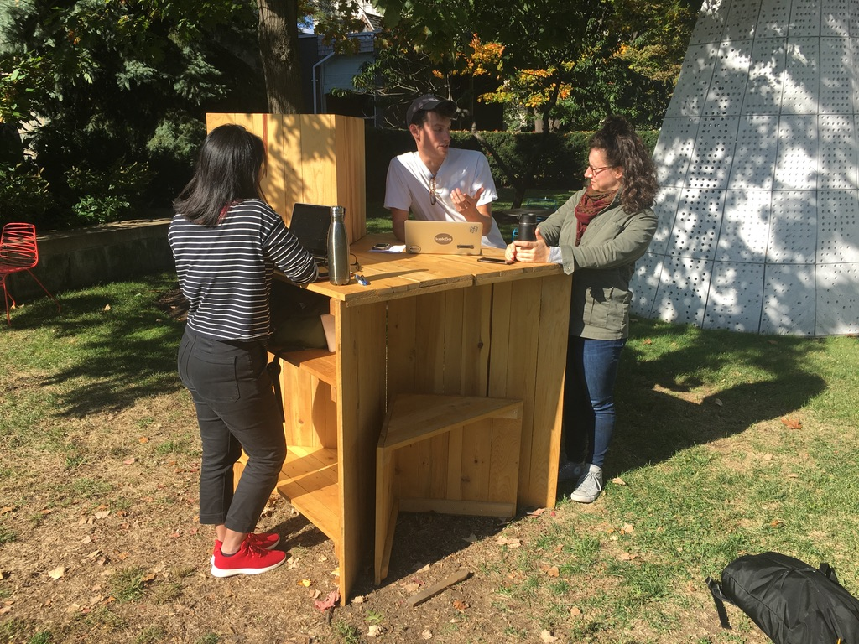

References
Neil E Klepeis, William C Nelson, Wayne R Ott, John P Robinson, Andy M Tsang, Paul Switzer, . . . William H Engelmann. (2001). The national human activity pattern survey (NHAPS): A resource for assessing exposure to environmental pollutants. Journal of Exposure Analysis and Environmental Epidemiology, 11(3), 231-52.

Bälter, O., Hedin, B., Tobiasson, H., Toivanen, Susanna, & Helena, Tobiasson. (2018). Walking outdoors during seminars improved perceived seminar quality and sense of well-being among participants. International Journal Of Environmental Research And Public Health, 15(303), International Journal of Environmental Research and Public Health, 2018, Vol.15(303).

Barreira, P., Basilico, M., & Bolotnyy, V. (2018). Graduate Student Mental Health: Lessons from American Economics Departments. Retrieved from https://scholar.harvard.edu/files/bolotnyy/files/bbb_mentalhealth_paper.pdf.

Berman M. G., Jonides J., Kaplan S. (2008). The cognitive benefits of interacting with nature.Psychol. Sci. 19 1207–1212. 10.1111/j.1467-9280.2008.02225.x

Boniface, M. (2006). The meaning of adventurous activities for ‘women in the outdoors’. Journal of Adventure Education & Outdoor Learning, 6(1), 9-24.

Broom, Catherine. (2017). Exploring the Relations between Childhood Experiences in Nature and Young Adults' Environmental Attitudes and Behaviours. Australian Journal of Environmental Education, 33(1), 34-47.

Chau, J., Grunseit, A., Stamatakis, E., Brown, W., Matthews, C., & Bauman, A. (2013). Daily Sitting Time and All-Cause Mortality: A Meta-Analysis. PLoS One, 8(11), E80000.

Cimprich, B. L., & Ronis, D. (2001). Attention and Symptom Distress in Women With and Without Breast Cancer. Nursing Research, 50(2), 86-94.

Egede, L. (2007). Major depression in individuals with chronic medical disorders: Prevalence, correlates and association with health resource utilization, lost productivity and functional disability. General Hospital Psychiatry, 29(5), 409-416.

Environmental Protection Agency. (2018, July 16). Indoor Air Quality. Retrieved from https://www.epa.gov/report-environment/indoor-air-quality

Hoskins, J. (2003). Health Effects due to Indoor Air Pollution. Indoor and Built Environment, 12(6), 427-433.

Kaiser Family Foundation. (2019, March 13). The U.S. Government and Global Non-Communicable Disease Efforts. Retrieved from https://www.kff.org/global-health-policy/fact-sheet/the-u-s-government-and-global-non-communicable-diseases/

Kent, S. T., McClure, L. A., Crosson, W. L., Arnett, D. K., Wadley, V. G., & Sathiakumar, N. (2009). Effect of sunlight exposure on cognitive function among depressed and non-depressed participants: a REGARDS cross-sectional study. Environmental health : a global access science source, 8, 34. doi:10.1186/1476-069X-8-34

Klepeis, N., Nelson, W., Ott, W., Robinson, J., Tsang, A., Switzer, P., . . . United States. Environmental Protection Agency. (2001). The national human activity pattern survey (NHAPS): A resource for assessing exposure to environmental pollutants. Journal Name: Journal of Exposure Analysis and Environmental Epidemiology; Journal Volume: 11; Journal Issue: 3; Other Information: Journal Publication Date: May-Jun. 2001.

Levandovski, R., Pfaffenseller, B., Carissimi, A., Gama, C. S., & Hidalgo, M. P. (2013). The effect of sunlight exposure on interleukin-6 levels in depressive and non-depressive subjects. BMC psychiatry, 13, 75. doi:10.1186/1471-244X-13-75

Lipson, SK et al. (2018) “Increased Rates of Mental Health Service Utilization by U.S. College Students: 10-Year Population-Level Trends (2007-2017).” Psychiatry ServicesNov. 5: appips201800332

Loeffler, T. (2004). A Photo Elicitation Study of the Meanings of Outdoor Adventure Experiences.
Journal of Leisure Research, 36(4), 536-556.

Mukeshimana, M., & Mchunu, G. (2017). Management of Co-Morbidity of Depression and Chronic Non-Communicable Diseases in Rwanda. Ethiopian Journal of Health Sciences, 27(1), 17-26.

Ohtsuka, Y., Yabunaka, N., & Takayama, S. (1998). Shinrin-yoku (forest-air bathing and walking) effectively decreases blood glucose levels in diabetic patients. International Journal of Biometeorology, 41(3), 125-127.

Panahi, S., & Tremblay, A. (2018). Sedentariness and Health: Is Sedentary Behavior More Than Just Physical Inactivity?. Frontiers in public health, 6, 258. doi:10.3389/fpubh.2018.00258

Park, B., Tsunetsugu, J., Kasetani, Y., Kagawa, T., & Miyazaki, T. (2010). The physiological effects of Shinrin-yoku (taking in the forest atmosphere or forest bathing): Evidence from field experiments in 24 forests across Japan. Environmental Health and Preventive Medicine, 15(1), 18-26.

Pearson, D. G., & Craig, T. (2014). The great outdoors? Exploring the mental health benefits of natural environments. Frontiers in psychology, 5, 1178. doi:10.3389/fpsyg.2014.01178

Tremblay, M., Colley, R., Saunders, T., Healy, G., & Owen, N. (2010). Physiological and health implications of a sedentary lifestyle. Applied Physiology, Nutrition, and Metabolism, 35(6), 725-740.
Ulrich, R. (1984). View through a Window May Influence Recovery from Surgery. Science, 224(4647), 420-421.

Van Den Berg, A., & Custers, M. (2011). Gardening Promotes Neuroendocrine and Affective Restoration from Stress. Journal of Health Psychology, 16(1), 3-11.

Wichrowski M., Whiteson J., Haas F., Mola A., Rey M. J. (2005). Effects of horticultural therapy on mood and heart rate in patients participating in an inpatient cardiopulmonary rehabilitation program.J. Cardiopulm. Rehabil. Prev. 25 270–274

World Health Organization. (2016, April 07). NCDs | Major NCDs and their risk factors. Retrieved from https://www.who.int/ncds/introduction/en/

Wu, D. W., DiGiacomo, A., & Kingstone, A. (2013). A sustainable building promotes pro-environmental behavior: an observational study on food disposal. PloS one, 8(1), e53856.

Zhai, Long, Zhang, Yi, & Zhang, Dongfeng. (2015). Sedentary behaviour and the risk of depression: A meta-analysis. British Journal of Sports Medicine, 49(11), 705-709.

